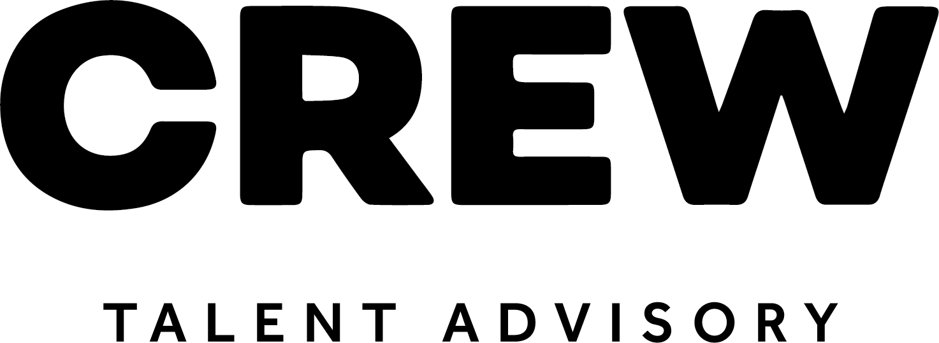

Interview Prep Plan Company Name:
JOB TITLE: DATE:
Hiring Manager/Interviewer: <Insert Linkedin Bio Hyperlink>
Job Description: <Insert JD link Hyperlink>
Role Location:
Company Values:
What have you learned from the website:
Example questions:
- What are your expectations for this position in terms of deliverables?
- In 6 months time, how will I know I’m meeting your expectations?
- What does your induction look like?
- What are the top initiatives on your plate right now?
- What are the top priorities as an organization?
- What are the biggest challenges your team faces?
- What advice would you give new starters in your team?
- What one thing do you think the team could be better at?
- What else do you want to know about my relevant experience?
- As you close your interview, consider saying:
- Do you want my help?
- Have you talked to other candidates?
- What did you like and not like?
- Do you have any concerns?
- What is your timeline and next steps?

